Name:_______________________
Date:_______________________
Period:_______________________
Assignment #:_________________
Building a Roller Coaster
DIRECTIONS: Using the link below, please use your knowledge of kinetic and potential energy to help you build a safe and thrilling roller coaster. Please, follow all of the steps thoroughly to ensure that you earn the best grade possible!
STEP 1:
Log on to http://content3.jason.org/resource_content/content/digitallab/4859/misc_content/public/Main.swf
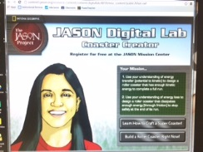
STEP 2:
Click on Learn How to Craft a Super Coaster and listen to all of the instructions on how to successfully build a roller coaster that has enough kinetic energy to complete a full run.
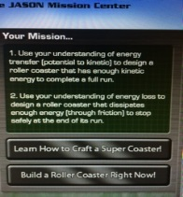
STEP 3:
Click on Build a Roller Coaster Right Now! Follow the steps to create a roller coaster. As you build your roller coaster please, complete the questions/chart below.
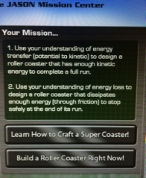
ROUND 1:
Name of car: _________________________________________________________________
Number of cars: ____________________
Mass: _____________________________
Hills: ____________m ___________________
Loops: ____________m ___________________
Difficulty: ____________ x__________________
Screams: ______________ _____________________
Top Speed:____________m/s _____________________
Stop Accuracy __________ _____________________
Overall Score: _______________________

ROUND 2:
Name of car: _________________________________________________________________
Number of cars: ____________________
Mass: _____________________________
Hills: ____________m ___________________
Loops: ____________m ___________________
Difficulty: ____________ x__________________
Screams: ______________ _____________________
Top Speed:____________m/s _____________________
Stop Accuracy __________ _____________________
Overall Score: _______________________

ROUND 3:
Name of car: _________________________________________________________________
Number of cars: ____________________
Mass: _____________________________
Hills: ____________m ___________________
Loops: ____________m ___________________
Difficulty: ____________ x__________________
Screams: ______________ _____________________
Top Speed:____________m/s _____________________
Stop Accuracy __________ _____________________
Overall Score: _______________________

What did you change about your roller coaster mass from Round 1, Round 2, to Round 3?
__________________________________________________________________________________________________________________________________________________________________________________________________________________________________________
What did you change about your roller coaster track from Round 1, Round 2, to Round 3?
__________________________________________________________________________________________________________________________________________________________________________________________________________________________________________
What tips would you give to someone in the other class periods about building a roller coaster?
__________________________________________________________________________________________________________________________________________________________________________________________________________________________________________
Below, sketch the roller coaster track that you created that earned the highest overall score:

